47U ENCLOSURE 19" CABINET 600X800 FLOOR STANDING DATA RACK - VALUCAB
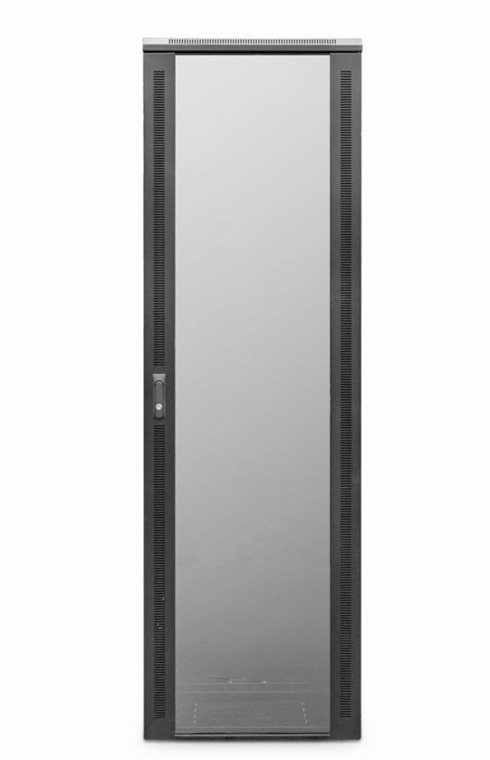

DESCRIPTION
The LMS Data ValuCab is the defacto standard in offering great choice and quality enclosure solutions, be it structured cabling for your copper or fibre networking, LAN or WAN networking deployment or broadcast A/V for companies of all sizes. Designed for the installer and IT manager, all network cabinets come with useful features to make your installation that much easier.

TECHNICAL SPECIFICATIONS
47U high 600W 800D - *SUPPLIED FLAT PACK ONLY*
• 19" standard
• Colour: Black (Powder-coated RAL 9005)
• Dimensions: 600 (width) x800(depth) x2320mm (height - inc. castors)
• Front tempered glass door (lockable)
• Left/right hinged front/rear doors
• Removable side panels for easy access
• U-numbered uprights for rack-mount product alignment
• Multiple cable entry glands for exact power and cabling entry

PRODUCT INFO
SKU/MNP: CAB-FE-47U-68NA
EAN: 8400800034731
Dimensions: 600 (width) x800(depth) x2320mm (height inc. castors) - when assembled

SUPPLIED WITH
Standard/Shipping Castors (Fitted): Set of 4 adjustable Jacking Feet (Supplied): Standard M6 Cage Nuts and Bolts (Supplied): Hex Adjusting Key (Supplied)
* NETBIT ONLY DELIVERS THESE CABINETS USING SAME DAY DELIVERY SERVICE - PLEASE CALL FOR A DELIVERY QUOTE *

FILES
﻿Specification Sheet (PDF)

